**Name: ____________________________**

**Introduction:** We have seen how mathematical models can be used to describe how populations grow and change over time, including exponential and logistic growth models for populations. In this activity, we will take a look at how we can apply mathematical models to understand how populations of different species can interact and how disruptions to ecosystems affect population dynamics.

This simulation is hosted on Google Colab, accessible through your Google account. You will be expected to make changes to the code present in this file. Read the instructions carefully.

**Part 1: Setup**

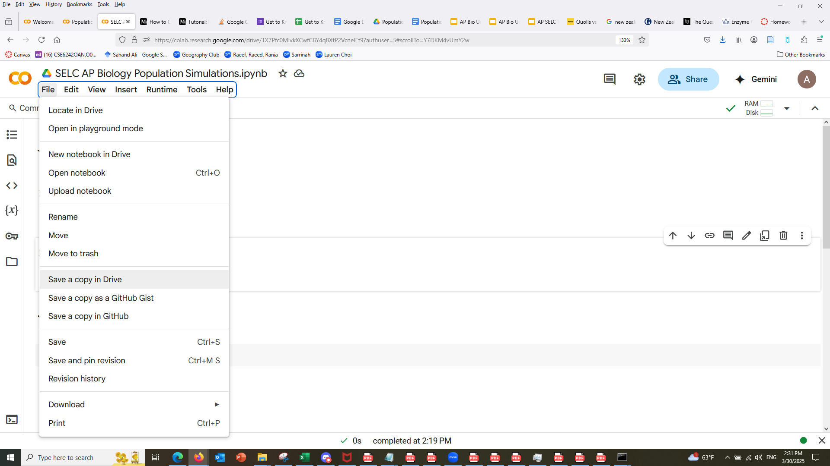

Open the simulation posted on Google Classroom. This simulation is written and coded in Python (you do not need to know Python for this activity). First, press “File” on the top panel before pressing “Save a Copy in Drive” (see image to the right). You will be working with this copy of this Google Colab notebook.

Once you have made your copy, find the “Runtime” menu and press the “Run all” button to execute all code cells. (See image to the right). *If a “release notes” menu appears, please close it.*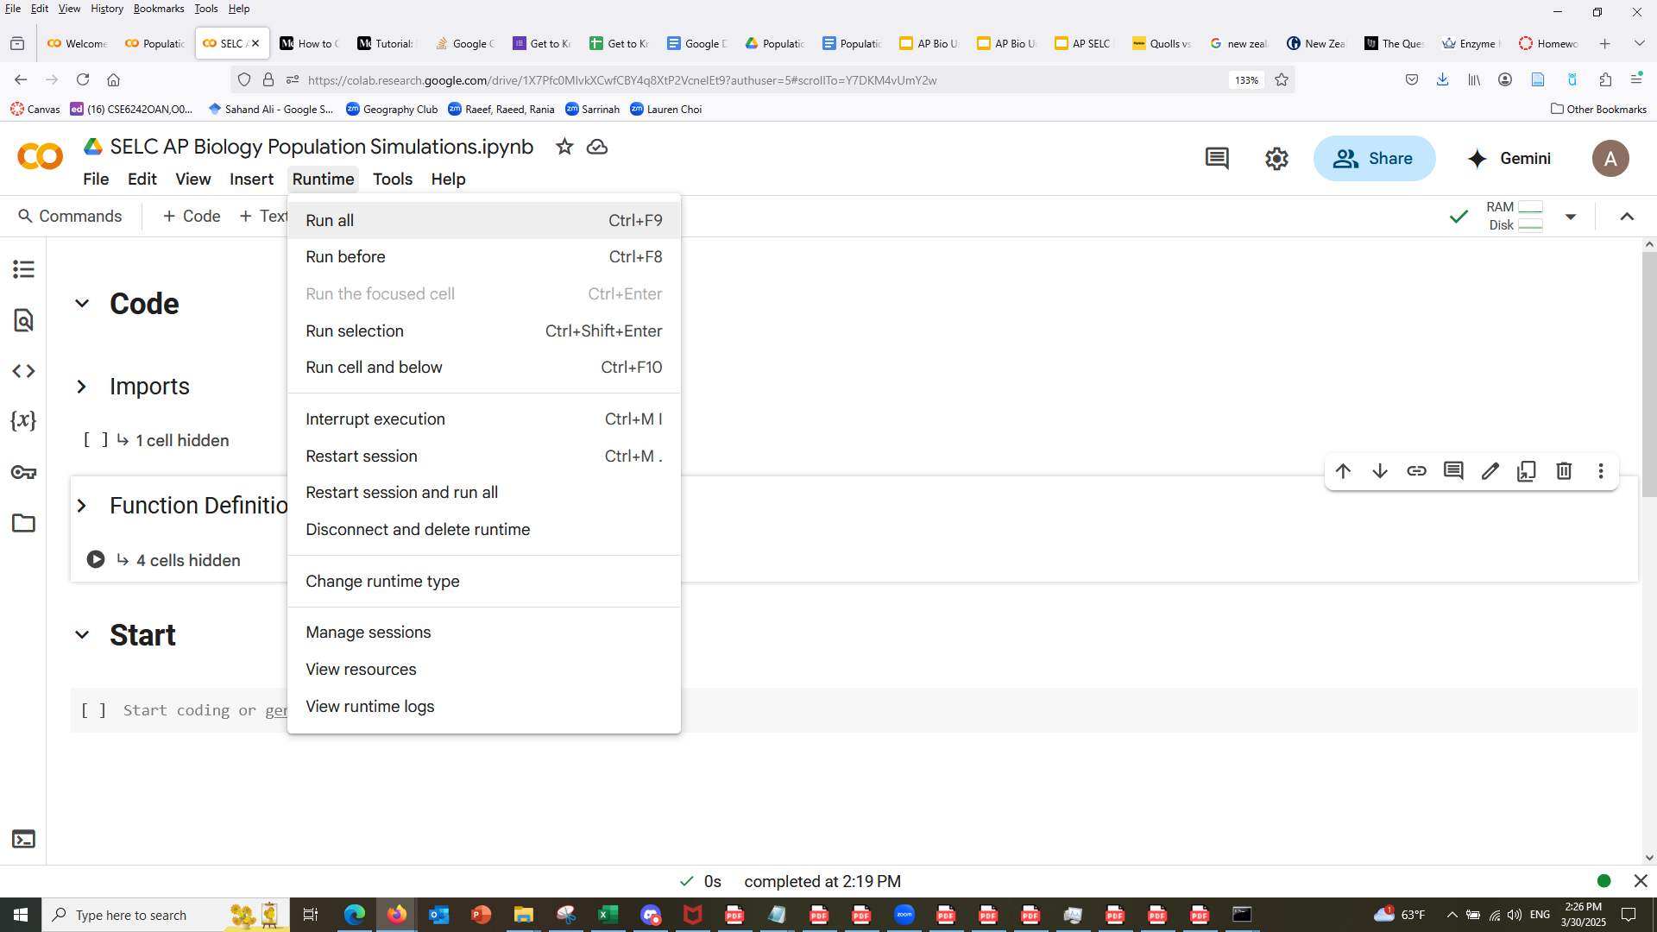

Once you have pressed “Run All”, scroll to the “Start” heading. You can hide the “Code” cells by pressing the drop-down arrow next to the header titled “Code”. Additional information will be provided in this document for you as you proceed.

Code in this file is organized in **cells**. To run a code cell, click on the cell to enter it and hold Shift+Enter to run it (try it out under Part 1: Setup). You can also press the “play” button to the left edge of the cell to run it:

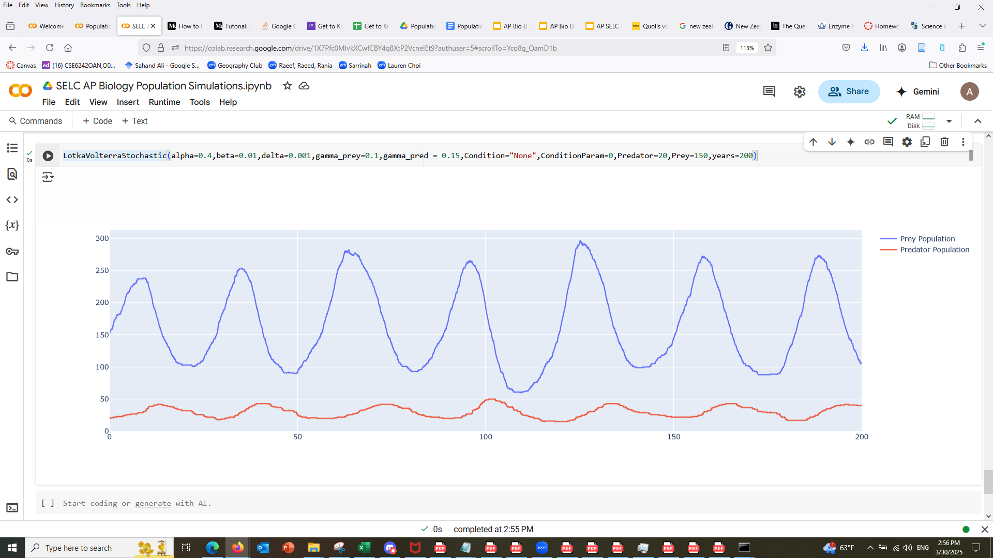

You can always collapse code cells or cell blocks using the dropdown arrows: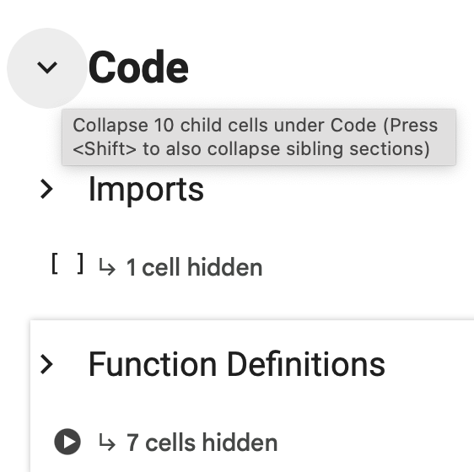

**Part 2: A Review of Exponential and Logistic Growth Models**

In past activities we have discussed exponential and logistic growth models for populations. Read through the section “Part 2: A Review of Exponential and Logistic Growth Models” and answer the questions below.

1. What shapes do exponential and logistic growth curves each take?
2. What happened to the rabbit population in the **exponential** growth model over 300 years? What are some factors this model does not take into account?
3. In the **logistic** model, **density-dependent** factors prevent a population from growing beyond a certain point called the **carrying capacity.** What are three factors that cause a population to “level off” as in the logistic growth model?
4. Take a look at the **E. coli, elephant, and hare** populations. Are E. coli r or K strategists? What about elephants? What about hares? Make determinations about **all three** populations using both evidence from the graphs **AND** evidence from your knowledge of bacteria and elephants. Write down your determinations for each and at least one piece of evidence for each.
5. For each of the three (E. coli, elephants, and hares), do they follow an exponential growth curve, a logistic growth curve, or neither?
6. Look at the human growth curve. Do we follow logistic or exponential growth? Why? List one density-dependent and one density-independent factor that affect human population growth.

**Part 3: Lotka-Volterra Model**

1. In this section the equation dN/dt = B - D is introduced. What are two factors that impact the birth rate of a population? What are two factors that impact the death rate of a population?
2. Under the “LotkaVolterraStochastic” model, the condition of sudden predator influx has been preloaded. This condition introduces 50 additional predators at the 100 year mark. **Why do prey go down as soon as these predators are added? Why do they skyrocket up again? Do the populations restabilize to the original wave-like pattern from the start?**
3. Plug in a different condition and play around with the condition parameter. What did you change? How did this affect predator and prey populations? Write a brief CER (at least 3 sentences total) about one trend/pattern that you observe. *(Be sure to run the same simulation a few times to see if the patterns you observe remain consistent, randomness in the simulation can lead to slightly different results each time.)*
4. Plug in a final condition and play around with the condition parameter. What did you change? How did it affect the predator and prey populations? Write a brief CER (at least 3 sentences total) about one trend/pattern that you observe.
5. Many conditions restabilize over time (get back to the original oscillating pattern or fully flatten out). Why is this pattern helpful for ecosystems?

**Part 4: Case Studies**

1. Why did the Chinese government wish to kill off sparrows?
2. Draw a simple food web showing the interactions between grain, locusts, and sparrows.
3. Run the code cell for the simulation. Sparrows were killed off most heavily between the years 1958 and 1962. What happened to the grain crop after the sparrows were killed off? What happened to the locust population?
4. Was the act of killing sparrows successful at protecting the Chinese grain crop? Why or why not?
5. Why did killing off such a small amount of life overall lead to such large changes in biomass for locusts and grain? Look back at your food web and think about how biomass compares between different trophic levels.
6. Run the New Zealand simulation. Draw a food web for native plants, native birds, rabbits, and stoats and indicate (with arrows, text, or otherwise) how the introduction of stoats affects the populations of the other species.
7. Look up an ecological phenomenon example from the list provided at the bottom of the Google Colab notebook. Follow the instructions provided. Use the space below to **write the phenomenon** you chose, **draw a (simple!) food web** for the key species involved, and **describe** the population dynamics in your phenomenon using vocabulary from this unit. If your phenomenon describes an ongoing problem, **explain** how ecological principles can be used to solve it. A vocabulary list is provided at the very end of the Google Colab notebook to help you.

Phenomenon & Food Web: